OVES BLE Charging Parameter Settings Guide
— A Practical Guide to Key BLE APP Parameters —
Project | OVES CG charging cabinet BLE parameter debugging
Target Device | Shenzhen-Service (CG charging cabinet)
Purpose | Explains the meaning and usage of key parameters: addr / auto / powr / time, etc.

1. Overview
This guide is intended for use with the BLE debugging APP (shown as “OVES CG…” / “Shenzhen-Service”). It explains how to write the commonly used parameters on the charging cabinet's BLE parameter page. During on-site commissioning, parameters can be read and written directly from the BLE device page of a smartphone, allowing the operator to switch charging modes, limit charging power or duration, and locate battery bay data.
1.1 Parameter Summary
Parameter | Meaning | Range | Default
addr | Device address (battery bay number) | 0 ~ N (N = number of charging bays) | 0
auto | Charging mode | 0 = Auto / 1 = Scan-to-charge | 0
powr | Charging energy limit (scan mode) | Unit: 100 mW·H | 0
time | Cumulative charging time (scan mode) | Minutes | 0

2. Writing “addr” — Locating a Battery Bay (Figure 1)
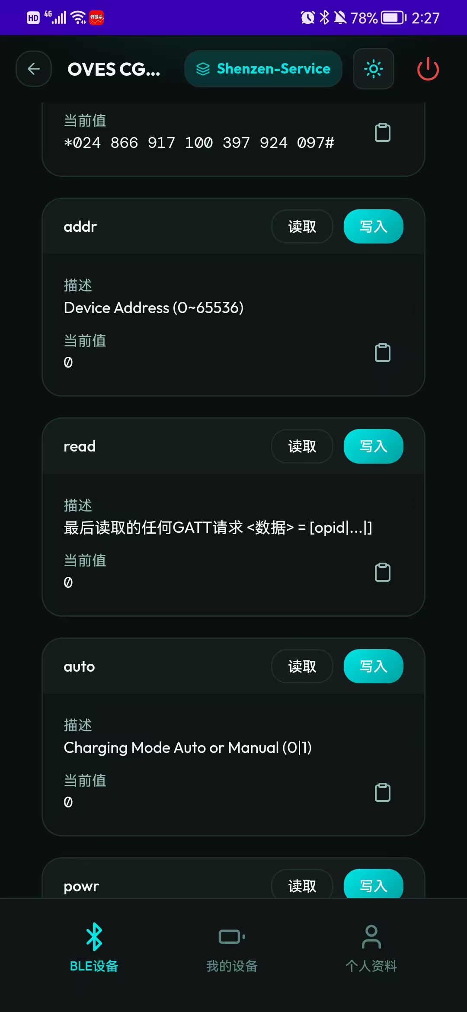
Figure 1 BLE parameter page — addr /
How to Operate
Perform a [Write] operation on the “addr” field to select the battery bay to be viewed or controlled. The writable value ranges from 0 to N, where N is the number of charging bays actually configured on the cabinet. For example, if N = 8, valid values are 0–8, corresponding to bays 1–8.
What Is Displayed
After an address is written, the battery data shown on the APP main page or log (voltage, current, temperature, SOC, etc.) corresponds to the battery installed in the selected bay, making it easy to inspect the status of each bay one by one on site.
Key Fields in Figure 1
Field | Description (as shown in APP) | Notes
addr | Device Address (0~65536) | Bay address to be written. The APP displays an upper limit of 65536, but the effective range is determined by the actual number of bays N.

3. Writing “auto” and “powr” — Charging Mode and Power (Figure 2)
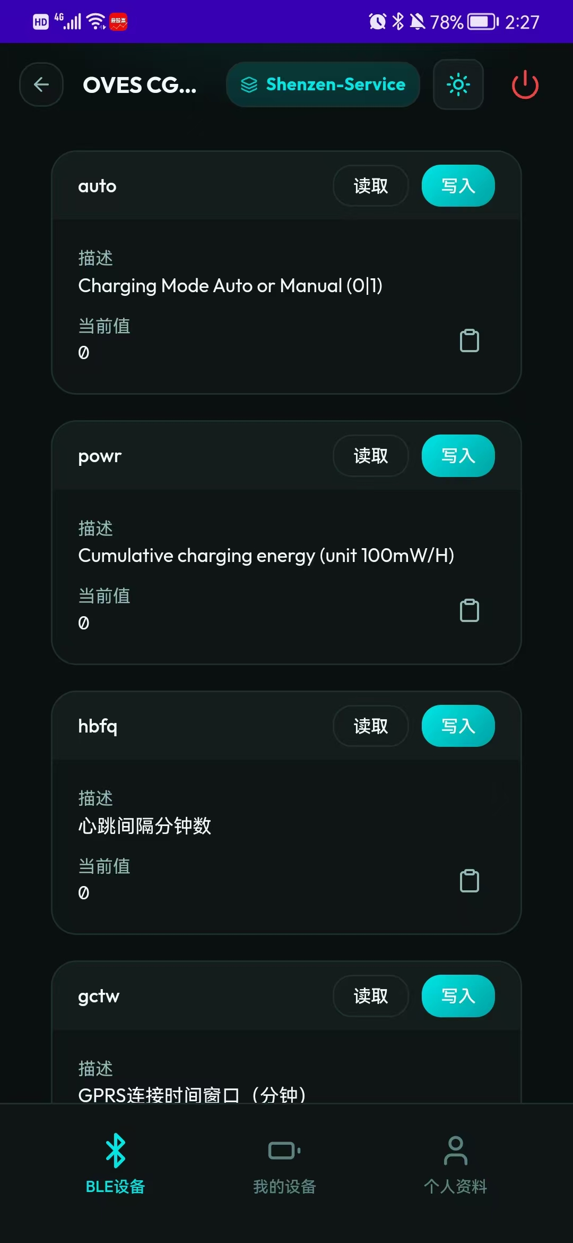
Figure 2 BLE parameter page — auto / powr / hbfq / gctw
3.1 auto — Charging Mode
Perform a [Write] operation on the “auto” field:
• Write 0 — Automatic charging mode: place the battery on the charging rack, connect the RCU's CAN bus, then install the battery; charging starts automatically, with no scan code or manual trigger required.
• Write 1 — Scan-to-charge mode: each charging session must be triggered by scanning a QR code. Suitable for order-based billing, per-session charging, or scenarios that require user identification.
3.2 powr — Charging Power (Scan Mode)
The “powr” field sets the cumulative charging energy limit in scan-to-charge mode, in units of 100 mW·H. During a scan-triggered charging session, charging stops automatically when the cumulative energy reaches the powr setting, or when the battery is detected as fully charged, preventing overcharging.
Note: when auto = 0 (automatic mode), powr generally does not take effect and charging stops according to the battery's own full-charge condition. powr only participates in the stop decision when auto = 1 (scan mode).

4. Writing “time” — Charging Duration in Scan Mode (Figure 3)
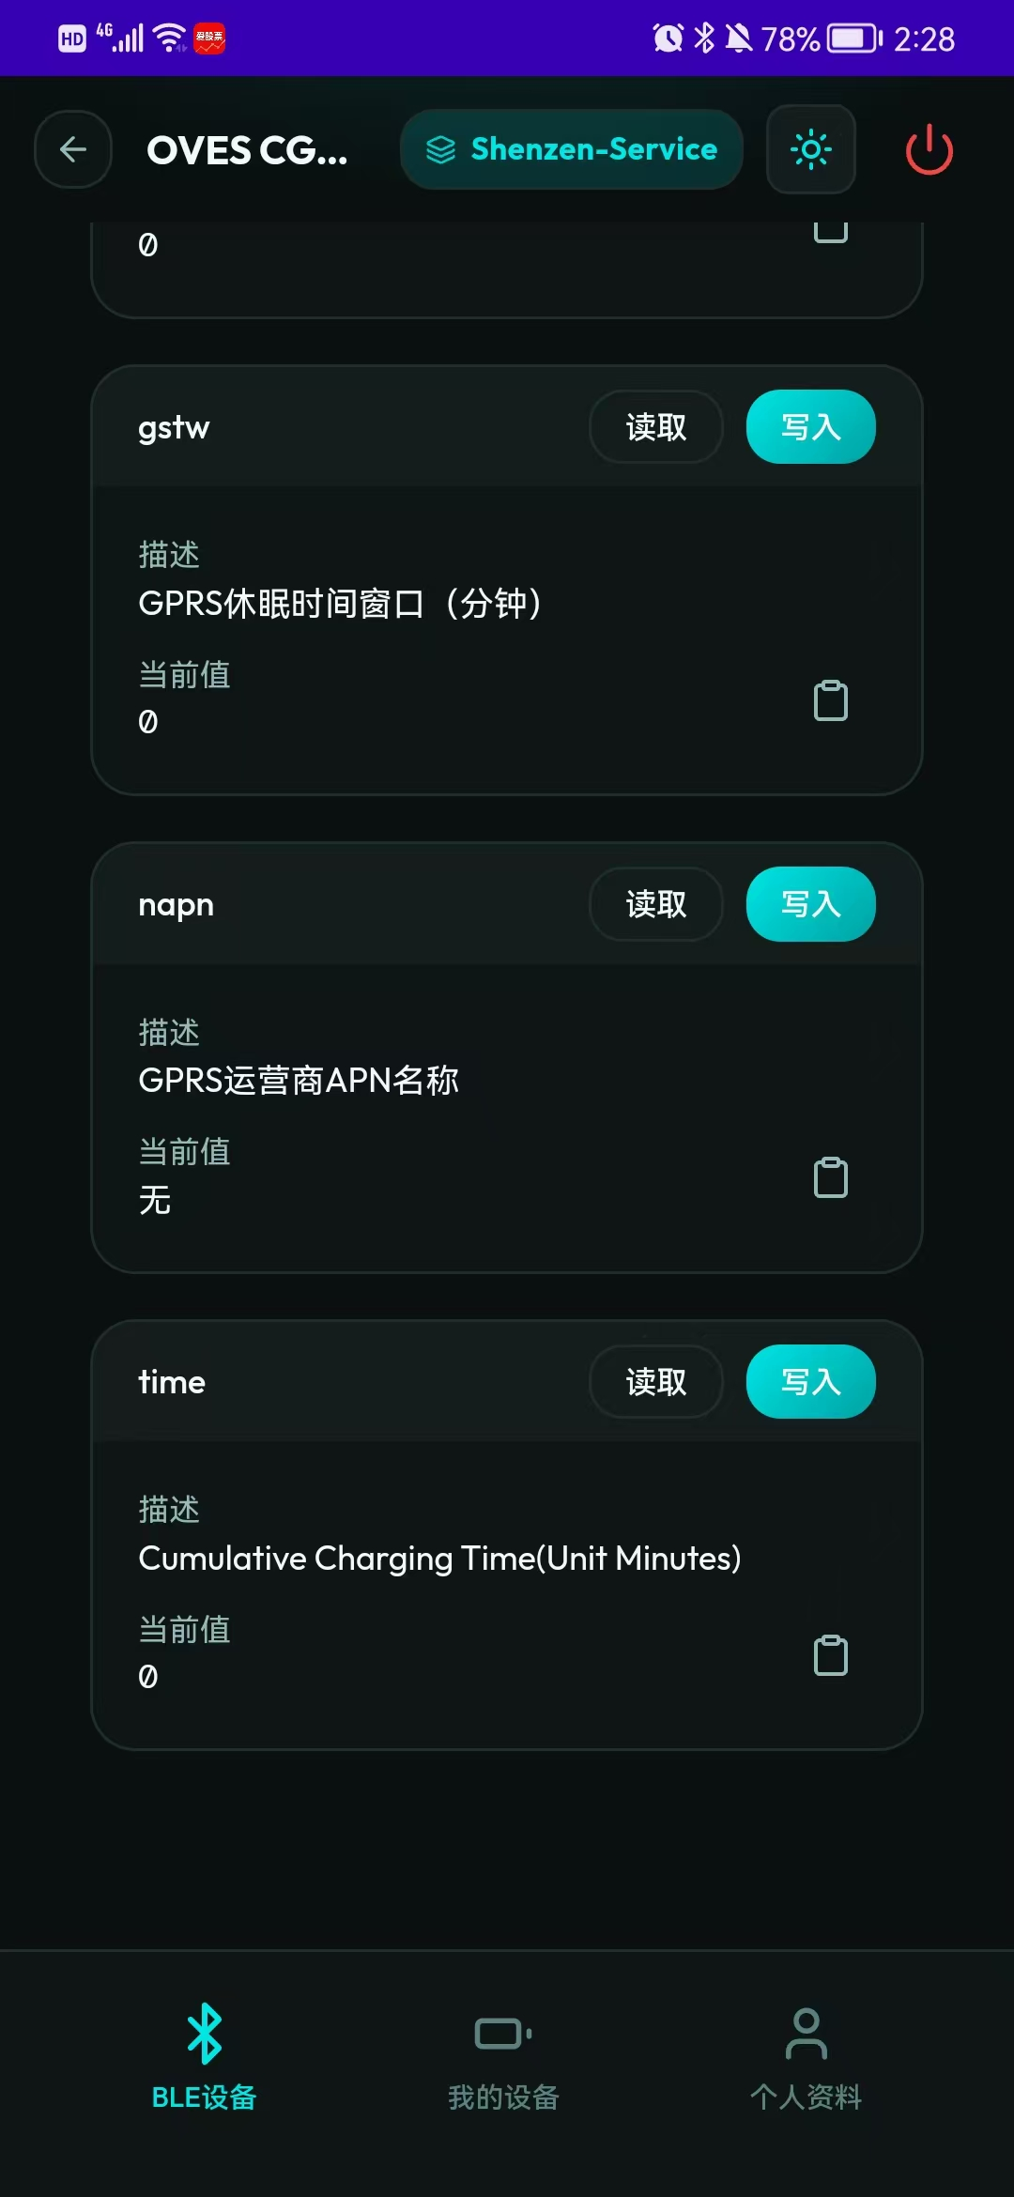
Figure 3 BLE parameter page — gstw / nqpn / time
How to Operate
Perform a [Write] operation on the “time” field to set the cumulative charging time limit in scan-to-charge mode, in minutes. When the cumulative duration of a scan-triggered session reaches the time setting, charging stops automatically, protecting the battery and controlling the cost of each session.
Using time Together with powr
In scan mode, time and powr are usually used together as two stop conditions:
① Cumulative charging energy reaches the powr setting → charging stops;
② Cumulative charging time reaches the time setting → charging stops;
③ The battery is detected as fully charged → charging stops.
Charging ends as soon as any one of the above conditions is met. Used together, the three conditions provide flexible control over per-session energy, duration, and safety margins.

5. Typical Configuration Examples
The following examples show recommended configurations for an 8-bay charging cabinet under different operating scenarios:
Scenario | auto | powr | time | Remarks
Automatic charging (maintenance/debugging) | 0 | — | — | No scan required; charging starts on insertion and stops when full.
Scan-to-charge · energy-based billing | 1 | 5000 | — | powr = 5000 (i.e. 500 × 100 mW·H); charging stops when reached.
Scan-to-charge · time-based billing | 1 | — | 120 | time = 120 minutes; charging stops automatically after 2 hours.
Scan-to-charge · dual protection | 1 | 5000 | 120 | Charging stops as soon as either condition is met — the safest option.

6. Precautions
1. Before writing any parameter, confirm that the BLE connection is established (the APP header shows “Shenzhen-Service”);
2. The addr value must not exceed the actual number of bays N, otherwise invalid data may be read;
3. After switching auto, wait 2–3 seconds before triggering a charge to ensure the new mode has taken effect;
4. powr is expressed in units of 100 mW·H — for example, 1000 = 100 W·H;
5. time is expressed in minutes; set it reasonably according to battery capacity and business needs to avoid durations that are too short or too long;
— End of Document —

